Interim Report
Group x500’s
mower023
leex8934
siew0053

Screen Captures
(Grabbing 0.txt)

Server Output
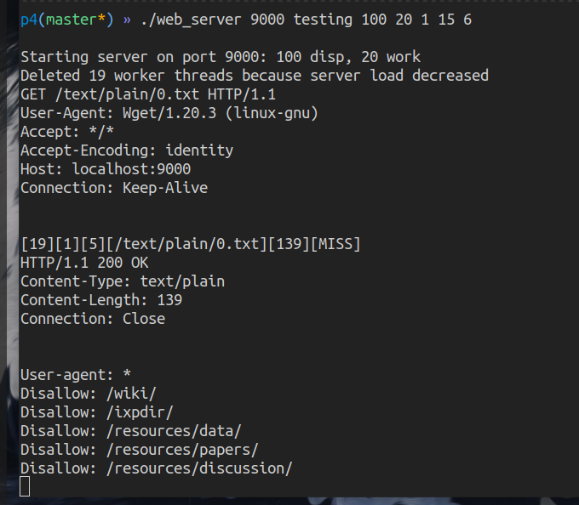
Wget Output
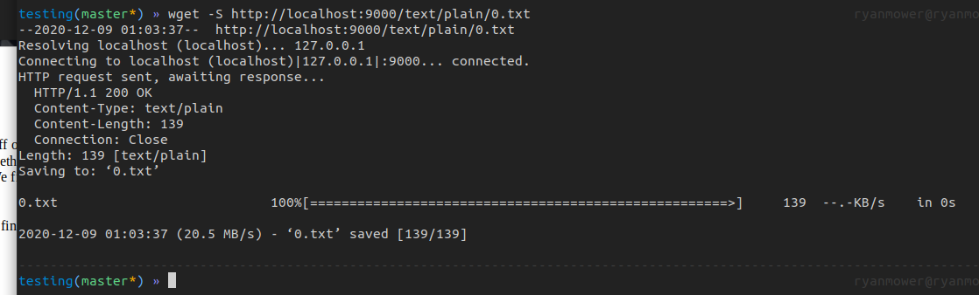

Plan for Work Distribution
Our group likes working synchronously because it allows us to bounce ideas off of each other and we are able to learn the entire project versus individual parts of the project. So we plan on working together for the rest of this project again. Working together includes finding times we are all free and coding together. We find this style most beneficial.

Plan for Extra Credit
As of now we do not have a plan for extra credit. Our goal at the moment is to finish Project 4 first and then to decide whether we should implement the extra credit.

